**CFX Framework:**

**Project Structure:**

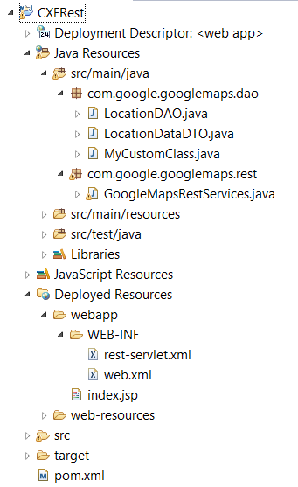

**Note: All the Previous codes we are using in the program will remain the same; we only have to make changes to web.xml and add one more rest-servlet.xml inside WEB-INF.**

**And make sure to add the CXF-dependencies in the pom.xml**

**Dependencies:**

<dependency>

<groupId>org.apache.cxf</groupId>

<artifactId>cxf-bundle-jaxrs</artifactId>

<version>2.2.9</version>

</dependency>

<dependency>

<groupId>javax.servlet</groupId>

<artifactId>servlet-api</artifactId>

<version>2.5</version>

</dependency>

**rest-servlet.xml Configuration:**

CXF uses a spring based configuration for registering its webservice endpoints so let us create a **rest-servlet.xml** in WEB-INF and after that configure the CXF in web.xml:

<?xml version=*"1.0"* encoding=*"UTF-8"*?>

<beans xmlns=*"http://www.springframework.org/schema/beans"*

xmlns:xsi=*"http://www.w3.org/2001/XMLSchema-instance"* xmlns:cxf=*"http://cxf.apache.org/core"*

xmlns:jaxws=*"http://cxf.apache.org/jaxws"* xmlns:jaxrs=*"http://cxf.apache.org/jaxrs"*

xsi:schemaLocation=*"*

*http://cxf.apache.org/core http://cxf.apache.org/schemas/core.xsd*

*http://www.springframework.org/schema/beans*

*http://www.springframework.org/schema/beans/spring-beans.xsd*

*http://cxf.apache.org/jaxrs http://cxf.apache.org/schemas/jaxrs.xsd*

*http://cxf.apache.org/jaxws http://cxf.apache.org/schemas/jaxws.xsd"*>

<import resource=*"classpath:META-INF/cxf/cxf.xml"* />

<import resource=*"classpath:META-INF/cxf/cxf-servlet.xml"* />

<import resource=*"classpath:META-INF/cxf/cxf-extension-jaxrs-binding.xml"* />

<cxf:bus>

<cxf:features>

<cxf:logging />

</cxf:features>

</cxf:bus>

<bean id=*"googleMapsRestServices"* class=*"com.google.googlemaps.rest.GoogleMapsRestServices"*/>

<jaxrs:server id=*"googleMapsRest_Services"* address=*"/cxf"*>

<jaxrs:serviceBeans>

<ref bean=*"googleMapsRestServices"* />

</jaxrs:serviceBeans>

</jaxrs:server>

</beans>

**Web.xml Configuration:**

<web-app xmlns=*"http://java.sun.com/xml/ns/javaee"* xmlns:xsi=*"http://www.w3.org/2001/XMLSchema-instance"*

xsi:schemaLocation=*"http://java.sun.com/xml/ns/javaee*

*http://java.sun.com/xml/ns/javaee/web-app_2_5.xsd"*

version=*"2.5"*>

<listener>

<listener-class>

org.springframework.web.context.ContextLoaderListener

</listener-class>

</listener>

<context-param>

<param-name>contextConfigLocation</param-name>

<param-value>WEB-INF/rest-servlet.xml</param-value>

</context-param>

<servlet>

<servlet-name>CXFServlet</servlet-name>

<servletclass>org.apache.cxf.transport.servlet.CXFServlet</servlet-class>

</servlet>

<servlet-mapping>

<servlet-name>CXFServlet</servlet-name>

<url-pattern>/rest/*</url-pattern>

</servlet-mapping>

</web-app>